EXPT NO:3 | CLEANSE DATA BY HANDLING MISSING VALUES, OUTLIERS, AND INCONSISTENCIES USING TABLEAU AND POWERBI
DATE: 10.07.2026

PRE-LAB QUESTIONS (PROVIDE BRIEF ANSWERS TO THE FOLLOWING QUESTIONS)

1. What are the potential impacts of missing values in a dataset, and what are some common strategies to address them in Tableau and Power BI?
Missing values can reduce data quality, introduce bias, and lead to inaccurate analysis or incorrect business decisions. They may also affect visualization accuracy and predictive model performance. In Tableau and Power BI, missing values can be handled by replacing them with suitable values, filtering incomplete records, or using calculated fields to assign default values. Data transformation tools such as Power Query and Tableau Prep also help identify and manage missing data efficiently.

2. What is the importance of identifying and addressing outliers in a dataset? How can outliers affect data analysis and model performance?
Outliers are data points that differ significantly from the rest of the dataset. They can distort statistical measures such as the mean and standard deviation, leading to misleading insights. In machine learning, outliers may reduce model accuracy and affect prediction quality. Identifying outliers through visualizations like box plots or scatter plots enables analysts to decide whether to remove, transform, or retain them based on their relevance to the analysis.

3. What types of data inconsistencies might you encounter during data cleansing, and how can Tableau and Power BI help in resolving them?
Data inconsistencies include duplicate records, inconsistent formatting, incorrect data types, spelling variations, and invalid values. These issues reduce data reliability and analysis accuracy. Tableau and Power BI provide data preparation features to standardize formats, change data types, remove duplicates, and clean inconsistent entries. Power Query and Tableau Prep offer transformation tools that simplify the data cleansing process and ensure the dataset is consistent for effective reporting and analysis.

4. How do you identify patterns in data using visualizations to spot missing values, outliers, and inconsistencies?
Visualizations help analysts identify data quality issues by presenting information in a clear and interactive format. Box plots can reveal outliers, scatter plots show unusual patterns, histograms display data distribution, and bar charts highlight missing or inconsistent values. Filters, color coding, and summary statistics further assist in identifying anomalies. Tableau and Power BI enable interactive exploration of datasets, making it easier to detect and resolve data quality issues before analysis.

5. What is the role of calculated fields in data cleansing, and how can they be used to handle missing values and outliers in Tableau/Power BI?
Calculated fields allow users to create custom expressions for cleaning and transforming data without modifying the original dataset. They can replace missing values with default values, categorize outliers, perform conditional calculations, and standardize data formats. In Tableau and Power BI, calculated fields improve data consistency and support accurate analysis by enabling dynamic transformations that automatically update when the underlying dataset changes, ensuring reliable visualizations and reports.

IN-LAB EXERCISE:
OBJECTIVE:
To clean a given dataset (e.g., Superstore Sample in Tableau and Financials/Sales Data in Power BI) by identifying and resolving missing values, outliers, and inconsistencies using built-in tools, ensuring the dataset is accurate and ready for analysis.

PROCEDURE:

Open the Tool and Connect Dataset
    - Open Tableau Desktop , Power BI Desktop.
    - Load the built-in dataset (Sample - Superstore in Tableau / Financials in Power BI).
    - Preview the dataset to understand its structure.

Initial Inspection
    - Explore fields such as Sales, Profit, Region, or Product Category.
    - Check for nulls, inconsistent text values (e.g., "South Region" vs. "South"), or date formatting issues.

Handling Missing Values
    - Use Data Interpreter (Tableau) / Power Query (Power BI) to highlight nulls.
    - Replace missing numerical values with mean/median, and text with "Unknown".
    - Use calculated fields: IFNULL([Field], Default) in Tableau or IF(ISBLANK([Field]), "Unknown", [Field]) in Power BI.

Detecting and Managing Outliers
    - Create scatter or box plots for Sales and Profit to identify extreme values.
    - Choose strategies:
      - Filter them temporarily.
      - Apply caps using calculated columns.

      - Flag them with labels for review.

Resolving Inconsistencies
    - Use Group/Alias (Tableau) / Replace Values (Power BI) to standardize text.
    - Normalize data formats, such as date fields or currency units.

Validation with Visuals
    - Build dashboards with histograms, bar charts, and box plots to visually confirm improvements.
    - Compare before/after cleaning stages for accuracy.

Save the Cleaned Dataset
    - Save as .twbx (Tableau) / .pbix (Power BI).
    - Optionally export cleaned data to .csv.

Summary Dashboard
    - Create a visual summary of the cleaning process, highlighting:
      - Fields corrected.
      - Nulls/outliers removed or adjusted.
      - Clean dataset metrics (record count, completeness %).

Experiment Dataset:
- Tableau: Sample - Superstore
- Power BI: Financials or Sales Data

How to Access:
Tableau:
  - Navigate to: Start Page → Sample Workbooks
  - Or: Help → Sample Data → Open Sample Data Folder
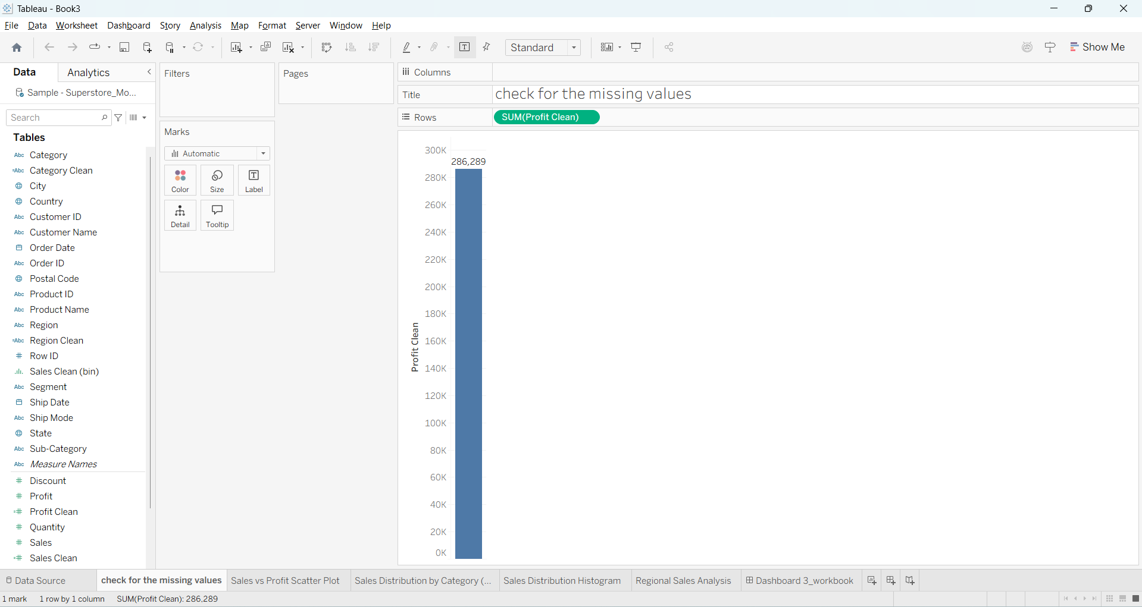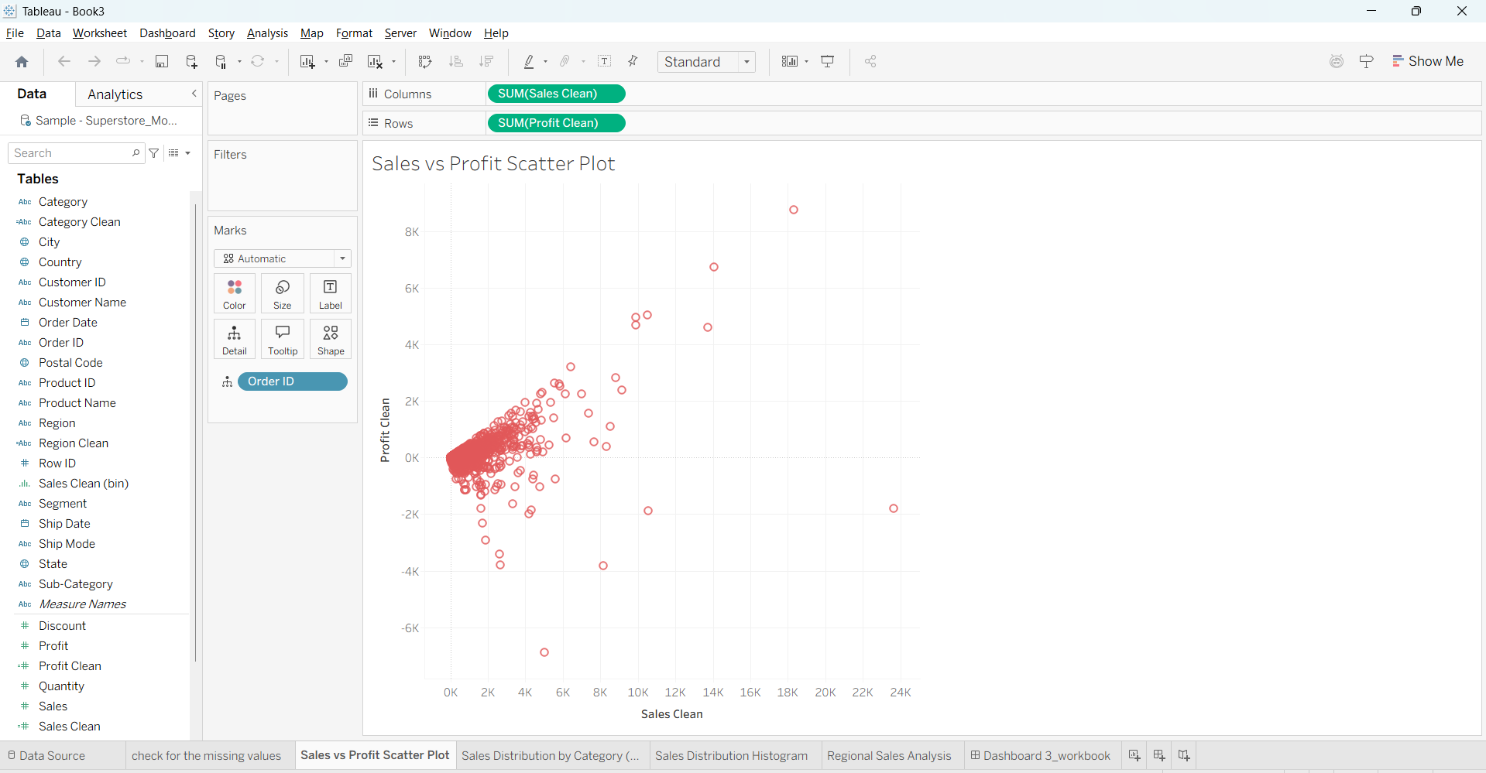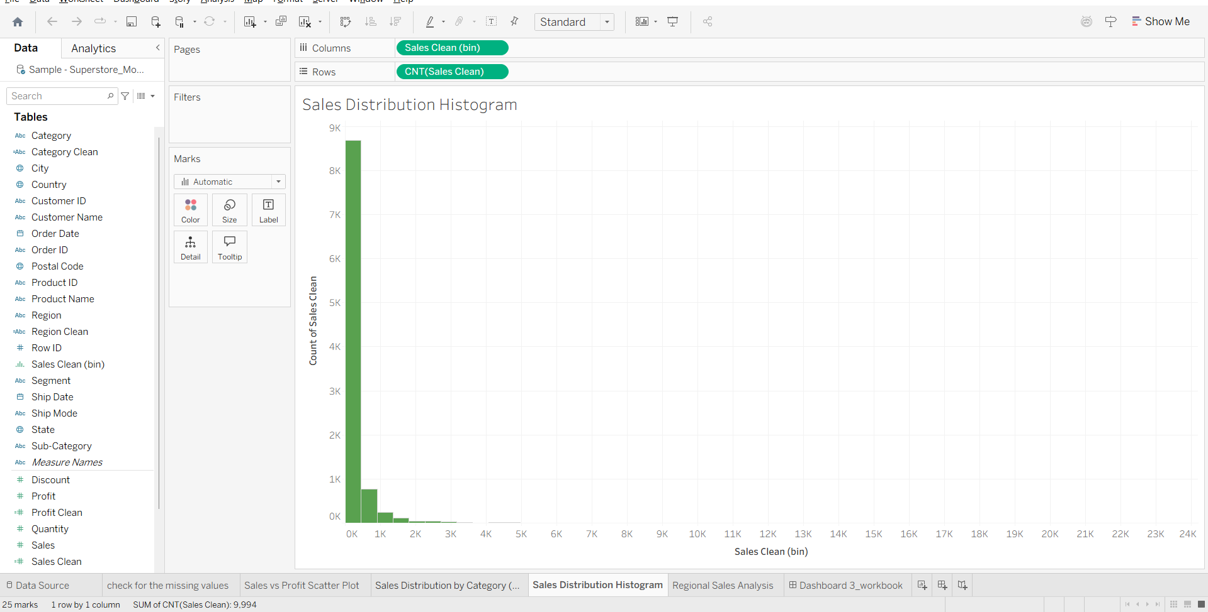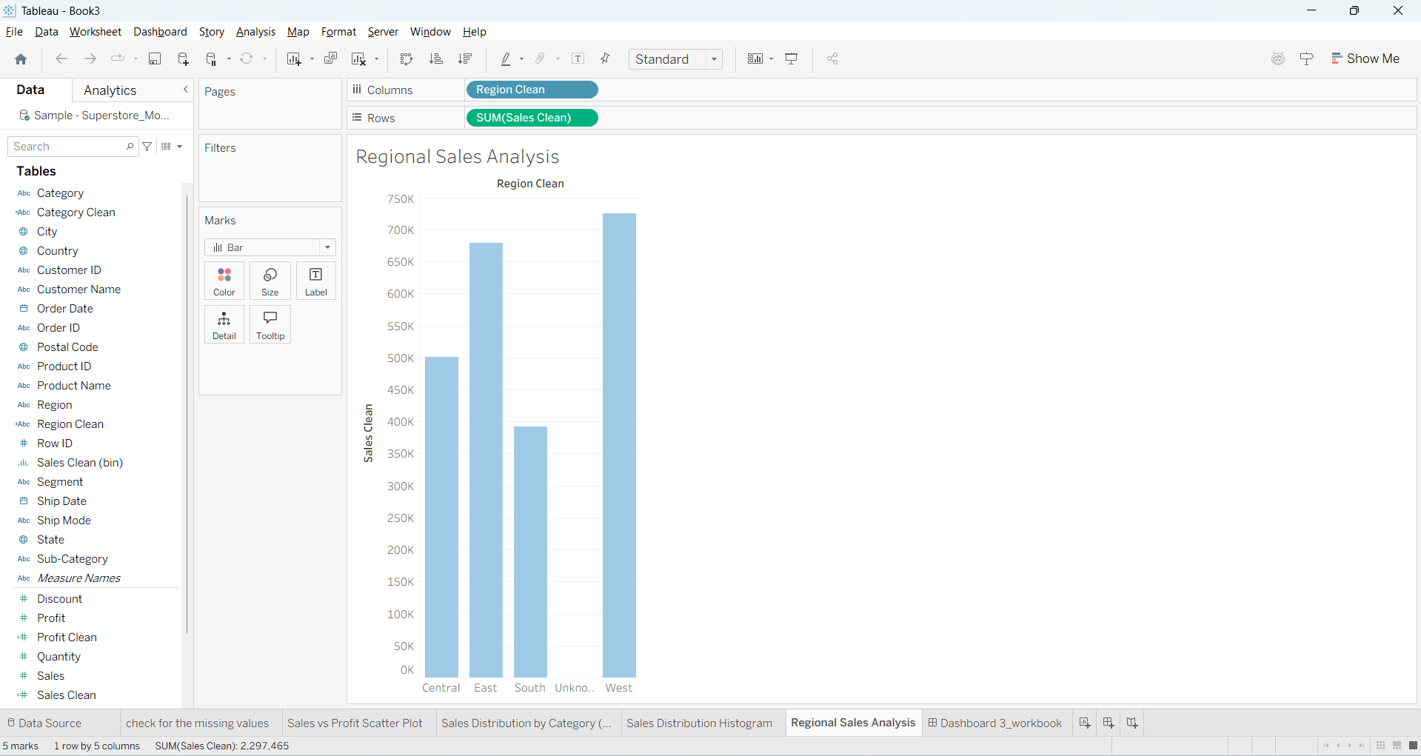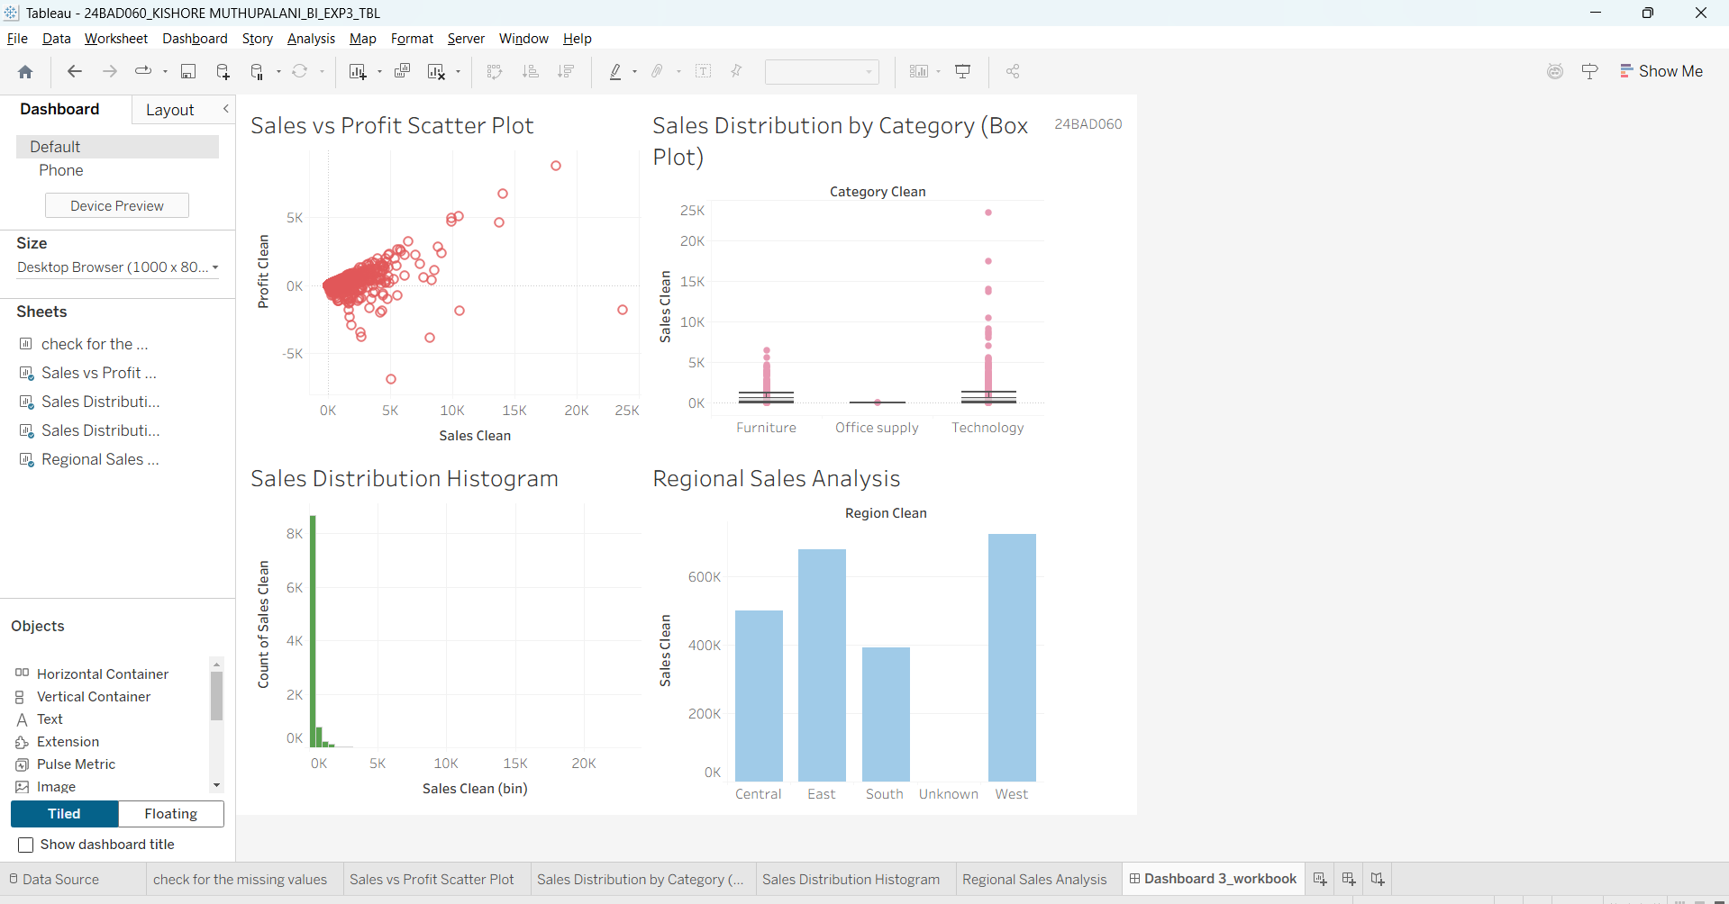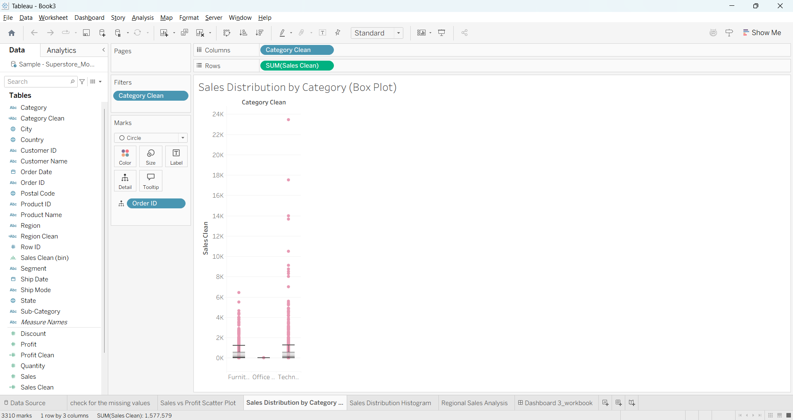

Power BI:
  - Navigate to: Home → Get Data → Excel → Choose sample datasets (e.g., Financial Sample.xlsx)
  - Microsoft also hosts Power BI sample datasets online.

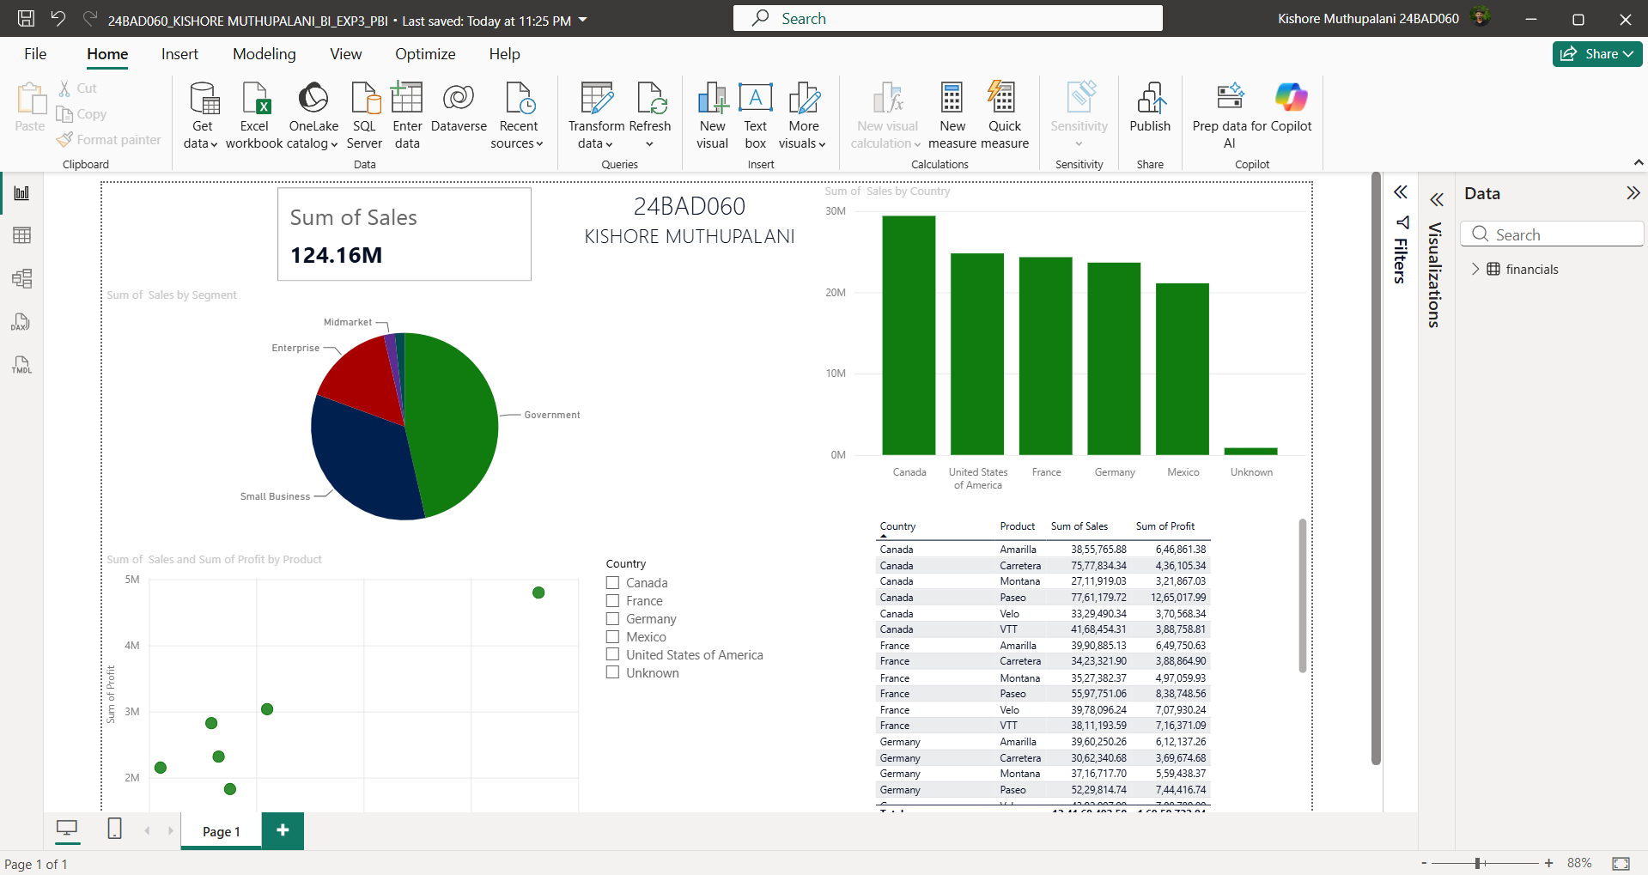

Fields Used:
- Sales
- Profit
- Region
- Category

- Order Date / Transaction Date

POST-LAB QUESTIONS (PROVIDE BRIEF ANSWERS TO THE FOLLOWING QUESTIONS)
1. What method did you use to replace missing values in numeric fields?
Missing values in the numeric attributes were identified during data profiling and replaced using the built-in data transformation features. Separate cleaned fields (Sales Clean and Profit Clean) were created to ensure that all null values were handled before visualization. The cleaning process eliminated blank records from the analysis, resulting in complete datasets for histograms, scatter plots, and regional sales analysis. This improved the reliability and consistency of the dashboard outputs.

2. How were outliers handled in your dataset and what visual confirmed their correction?
Outliers were identified using the Sales Distribution by Category (Box Plot), where observations outside the whiskers indicated abnormal sales values. After reviewing these records, extreme values were treated appropriately during the data preparation stage to reduce their influence on the analysis. The effectiveness of the correction was verified through the updated box plot and the Sales Distribution Histogram, which showed a more consistent distribution without unnecessary distortion caused by extreme values.

3. What inconsistencies were detected in categorical values and how were they standardized?
Categorical inconsistencies were observed in fields such as Region and Category, where inconsistent naming and formatting could affect grouping and aggregation. Standardized fields (Region Clean and Category Clean) were created by correcting spelling differences, removing unwanted spaces, and ensuring uniform text formatting. This standardization ensured that records belonging to the same category were grouped together correctly, improving the accuracy of regional comparisons and category-wise sales analysis.

4. Describe how calculated fields helped in resolving data issues.
Calculated fields played a significant role in preparing the dataset for analysis. Cleaned fields such as Sales Clean, Profit Clean, Region Clean, and Category Clean were created to replace missing values, standardize categorical data, and provide consistent inputs for visualizations. These calculated fields preserved the original dataset while generating cleaned versions for reporting, ensuring that all dashboard visuals reflected accurate and reliable information without modifying the source data directly.

5. How did your dashboard demonstrate the effectiveness of the data cleaning process?
The dashboard demonstrated the success of the cleaning process through consistent and meaningful visualizations. The Regional Sales Analysis displayed correctly grouped regional values, the Sales Distribution Histogram showed a smooth distribution without missing records, the Category Box Plot highlighted properly managed outliers, and the Sales vs Profit Scatter Plot presented a clearer relationship between the two measures. Together, these visualizations confirmed that missing values, outliers, and categorical inconsistencies had been effectively resolved before analysis.

RESULT:

Description | Max Marks | Marks Awarded
Pre Lab Exercise | 5
In Lab Exercise | 10
Post Lab Exercise | 5
Viva | 10
Total | 30
Faculty Signature
The dataset was successfully cleaned and prepared for accurate analysis using Tableau and Power BI. Issues such as nulls, inconsistencies, and outliers were identified and resolved, improving data quality significantly.

ASSESSMENT

